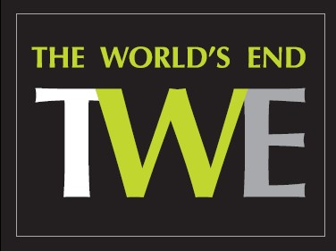
PIZZA/PASTA FRIDAY
2 for the price of 1
(OFFER FOR DINING IN ONLY)

12-2PM & 6.00PM-8.30PM

STONE FIRED PIZZA
Fresh pizza dough made daily at TWE, rolled to make our famous thin crust pizzas with fresh plum tomato sauce and grated Italian mozzarella.

Margherita, £14.95 V
(Swap to Vegan Cheese +£2)

Add your toppings:
£1.50 each: ham, chicken, chorizo, beef, smoked salmon, prawns
£1 each: smoked bacon, fresh chili, mushrooms, gherkins, red onion, peppers.

PASTA

Creamy chicken & mushroom penne £18.95
Prawn, chorizo & tomato linguine £18.95
Spicy tomato & fresh chilli penne arrabiata £17.95 V
Classic spaghetti bolognese £18.95

Add: Garlic & mozzarella OR Parmesan & basil ciabatta £2.25

